Raport 1.
1.Raport (k-średnie)

Iteracja 1
Grupa | Środek wartości (Centroid) | Liczba próbek | Max (x, y) | Min (x, y)
Grupa 1 | [-1.13189, 1.09029] | 30 | [0.0322, 1.9473] | [-0.0824, 0.9435]
Grupa 2 | [0.16600, 0.54080] | 23 | [-1.6954, -0.2604] | [0.0913, 0.9575]
Grupa 3 | [0.28679, -0.90578] | 48 | [-1.4969, -0.7615] | [1.1175, 0.3286]

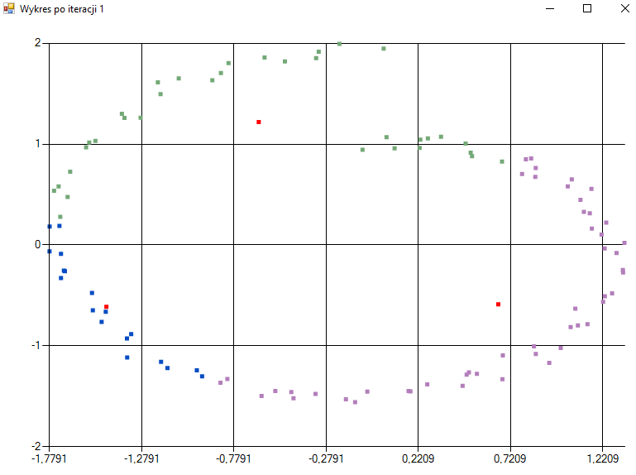

Iteracja 4
Grupa | Środek wartości (Centroid) | Liczba próbek | Max (x, y) | Min (x, y)
Grupa 1 | [-1.30514, 0.87226] | 31 | [-0.2074, 1.9929] | [-1.5441, -0.6479]
Grupa 2 | [0.83689, 0.45340] | 36 | [0.0322, 1.9473] | [-0.0824, 0.9435]
Grupa 3 | [-0.17769, -1.22626] | 34 | [-1.4743, -0.6608] | [1.0461, -0.8127]
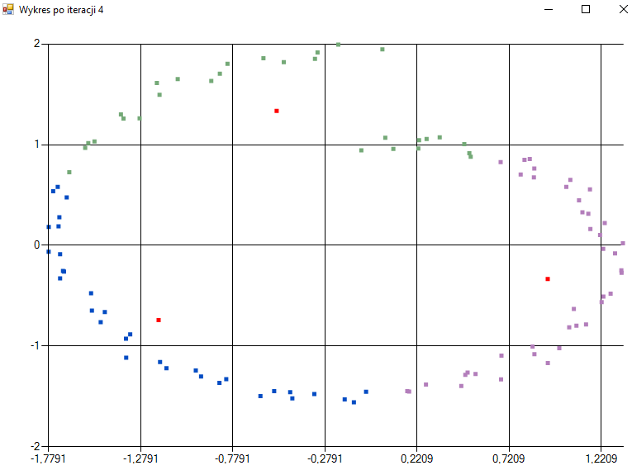

Iteracja 8 (Stabilizacja)
Grupa | Środek wartości (Centroid) | Liczba próbek | Max (x, y) | Min (x, y)
Grupa 1 | [-1.25429, 0.95598] | 31 | [0.0322, 1.9473] | [-1.5488, -0.4747]
Grupa 2 | [0.87099, 0.34501] | 37 | [1.1371, -0.7834] | [-0.0824, 0.9435]
Grupa 3 | [-0.29444, -1.23427] | 33 | [-1.4743, -0.6608] | [0.9918, -1.0194]
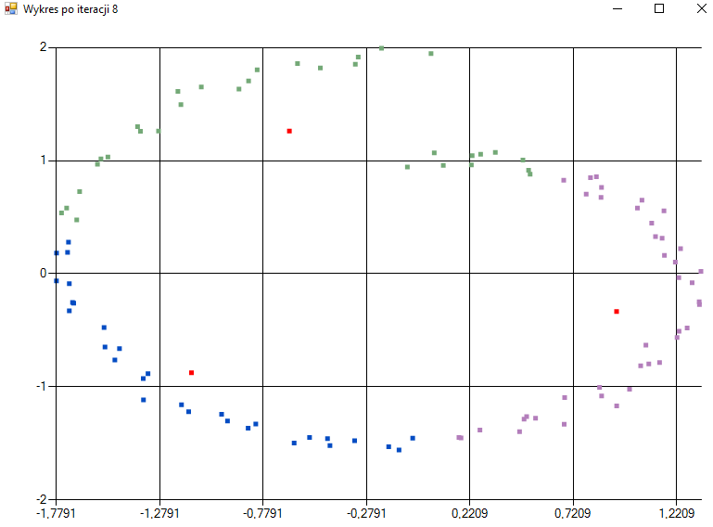
Iteracja 10 (Algorytm zakończony)
Grupa | Środek wartości (Centroid) | Liczba próbek | Max (x, y) | Min (x, y)
Grupa 1 | [-1.25429, 0.95598] | 31 | [0.0322, 1.9473] | [-1.5488, -0.4747]
Grupa 2 | [0.87099, 0.34501] | 37 | [1.1371, -0.7834] | [-0.0824, 0.9435]
Grupa 3 | [-0.29444, -1.23427] | 33 | [-1.4743, -0.6608] | [0.9918, -1.0194]
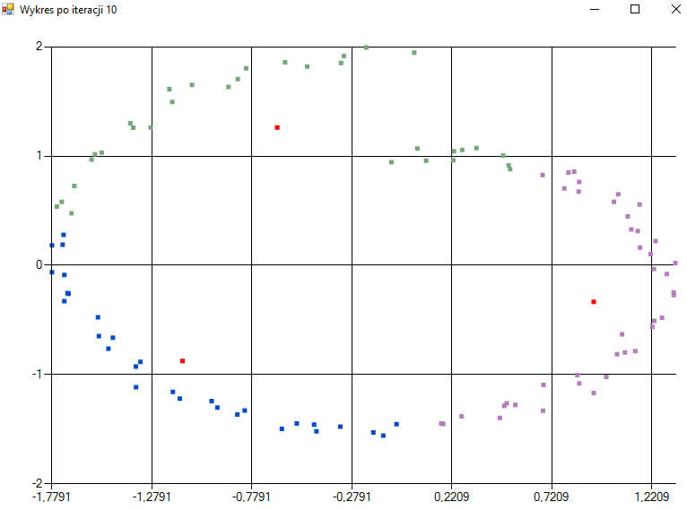

Raport 2.
2.Raport (k-średnie)
Numer grupy | Środek wartości (x, y) | Liczba próbek | Maksymalna wartość (x, y) | Minimalna wartość (x, y)
1 | [-1.328376, 1.113914] | 21 | [-0.5031, 1.8191] | [-1.7251, 0.1885]
2 | [0.646113, 0.798944] | 32 | [0.0322, 1.9473] | [-0.0824, 0.9435]
3 | [0.897205, -0.919480] | 20 | [0.2684, -1.3820] | [1.3301, -0.2716]
4 | [-0.967736, -1.032107] | 28 | [-1.7790, -0.0625] | [0.1669, -1.4465]


